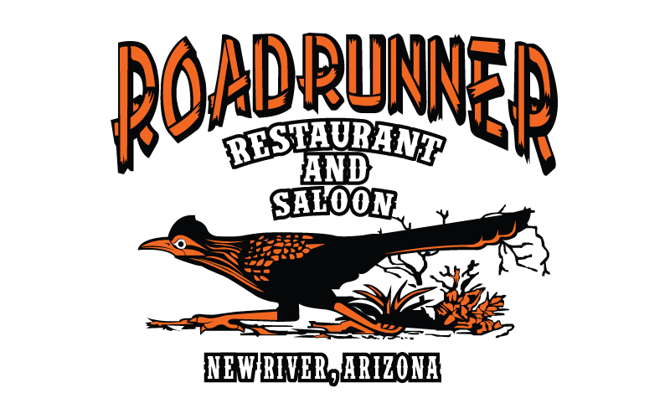

Roadrunner Restaurant & Saloon Advertising Form
Thank you for your interest in advertising at the Roadrunner Restaurant and Saloon.
Please complete the form below with your information to advertise with us!

Advertising Levels Include Your Logo Featured on Our Website Plus:
- 4x8 Courtyard Fence – $1000 / Year
- 3x7 Beer Garden Banner – $3000 / Year
- 4x6 Sound Booth Banner - $4000/ Year
- 4x8 Back of Stands – $3000 / Year
- Bucking Chutes – $4000 / Year (7" x 2" x 22" – Metal Only)
- 4x8 Return Gate – $5000 / Year
- 4x8 Announcers Stand & Boards Above Speakers– $12000 / Year
- 4x8 Roadrunner Stage – $9000 / Year
- 4x8 Street Sign - $10,000/Year

Advertising Information:
Owner's Name: ________________________________ Business Name: ________________________________
Address: _________________________________________________________________________________________
City: ________________________________ Email: ________________________________
Website: ________________________________

Advertising Level (check all that apply):
☐ Courtyard Fence ☐ Beer Garden Banner ☐ Back of Stands
☐ Street Sign ☐ Announcers Stand & Above Speakers ☐ Roadrunner Stage
☐ Sound Booth ☐ Bucking Chutes ☐ 1 Year

Payment Information:
Please make checks payable to The Roadrunner Restaurant & Saloon
By signing below, you acknowledge your commitment to the advertising level selected above and agree to provide the required payment and promotional materials (e.g., logos).
Signature: ___________________________________________ Date: ____________________

Any Questions?
Please call 602-480-5238

